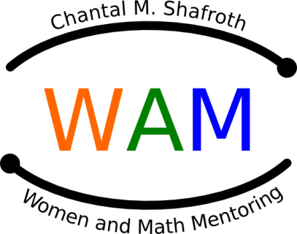
Women & Math Mentoring Program

Mentor Application and

Information Form

Name:
Company or University:
Job Title:
Job Description: ___________________________________________________________________
Department: ______________________________________________________________________
Mailing Address: __________________________________________________________________

________________________________________________________________________________
Phone: (w)__________________ (h)____________________ (c)___________________________
Preferred e-mail address: ___________________________________________________________

What languages other than English do you speak? ________________________________________

________________________________________________________________________________

How did you learn about the Math Mentoring Program?___________________________________

________________________________________________________________________________

________________________________________________________________________________
T-shirt size: Adult S, M, L, XL, XXL __________

School Preference: Brogden, Carrington, Durham School of the Arts, Githens, Lakewood, Little River, Lowes Grove, Lucas, Neal, Rogers-Herr, School for Creative Studies, Shepard (google map)

1st choice: _________________ 2nd choice: ____________________ 3rd choice: _______________________

Requirements:

Do you have transportation to take two or three girls from school to a field trip? _____
Pre-arranged field trips are usually scheduled weekdays late afternoon, requiring absence from school/work. From January through May, do you have time to take at least 1 day off (8am – 3pm) AND at least an afternoon/evening (after 2:00) once a month? ______

Date_____________________

Please send this form to applications@womenandmathmentoring.org.

For more Information, visit the web site: www.WomenandMathMentoring.org and check out the get involved page: http://www.womenandmathmentoring.org/getInvolved.php

** Please note that the Durham Public Schools system performs background checks on all volunteers, including mentors in the WAM program.

